SCIENCE CAMP

When: June 5-9, 2017 Where: Hattie Watts Elementary Ages: Currently in First – Fifth Grade Time: 8:00am – 3:00pm (Bring your lunch) - Cost: $125.00 or Time: 8:00am – 11:00am - Cost: $75.00

CHECK OUT PICTURES OF SCIENCE CAMP ON OUR FACEBOOK PAGE
https://www.facebook.com/HWEsciencecamp/
-----------------------------------------------------------------------------------------------------------------------------

Registration Form for SUMMER SCIENCE CAMP 2017:
Student Name: _______________________ Grade: ____ Teacher Name: _________________
Parent Name: ________________________ Phone Number: ___________________________
Check off one camp time that your child will attend: _____ 8:00-3:00 _____8:00-11:00
Children attending the 8-3 session will need to pack a lunch and bring it to camp with them.

Space is limited. First come first serve. Send the registration form and payment of $75.00 for 8:00-11:00 or $125.00 for 8:00-3:00 as soon as possible. Deadline for payment is Friday, May 12th at 3:00. Make checks payable to Christy LeBlanc. Local checks only. No Refunds. Please detach the top part so you will have times and dates. Send the rest of the registration form and payment to school in an envelope labeled Science Camp.

Information Sheet for SCIENCE CAMP

Student Name: _____________________________________ Grade Next Year: ______
Parent/Guardian’s Name: ____________________________________________________
Parent/Guardian’s Phone Number: (Work) ____________________________________
(Cell) _____________________________________
(Home) ___________________________________
Physical address: ___________________________________________________________
Emergency contacts & phone numbers (minimum of 2):
Name: _____________________________ Phone Number: __________________
Name: _____________________________ Phone Number: __________________
Food Allergies; check all that apply: ___peanut, ___eggs, ___sugar, ___milk, other_______________________________________________________________
Medicine Allergies: _________________________________________________________
Medical Concerns; check all that apply: ___asthma, ___seizures, ___nose bleeds
___bladder problems, other _________________________________________________
***If a parent/guardian can’t be reached, Science Summer Camp staff has the right to seek medical attention.
How will your child go home after Science Camp? ___Walk ___Car Rider (pick up promptly.)
PARENT SIGNS BEHAVIOR AGREEMENT:
I, _________________________, understand that my child will be dismissed from the science camp if he/she is unable to maintain good behavior and follow the rules of the camp. Refunds will not be given.
PARENT SIGNS COPYRIGHT AGREEMENT:
I, ______________________, consent to pictures/videos being taken of my child during Science Camp. Pictures/Videos may be used on social media, flyers, newspaper, or anything to do with Science Camp. You may view your child’s pictures/videos on the Facebook webpage for Science Camp at the following address: https://www.facebook.com/HWEsciencecamp/ _____ Yes I consent _____ No I don’t consent
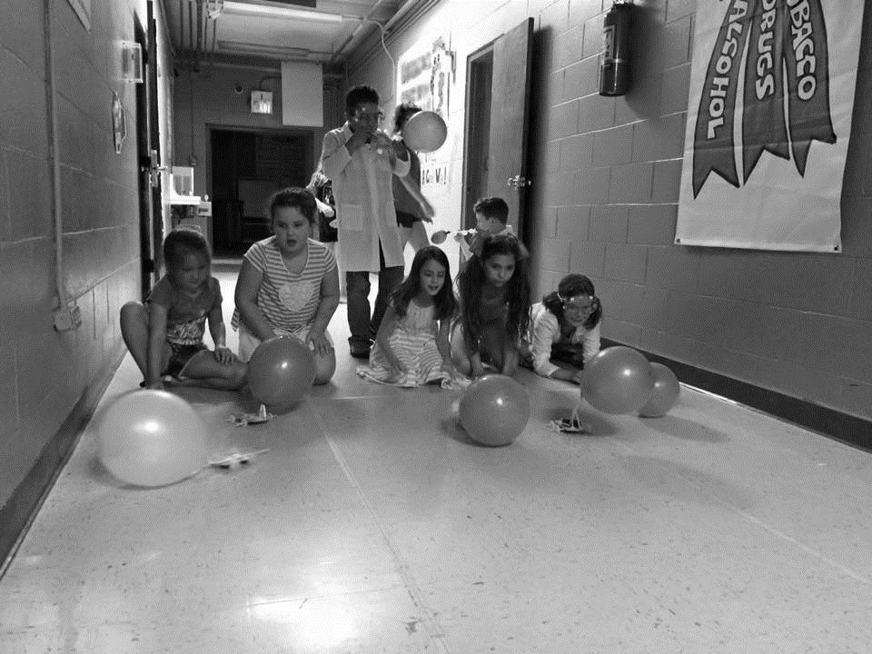
SCIENCE CAMP
Possible Experiments
*creating water tornadoes
*making soda bottle rockets
*growing crystals
*creating doodle robots
*making blood
*blowing up balloons with pop rocks
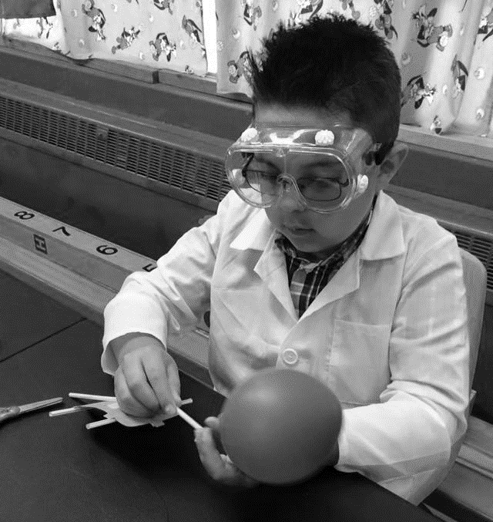
*making secret spy ink
*quick sand

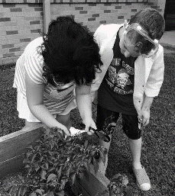
EXTRAS
Games:
Mad Scientists Dance Freeze
Mad Scientist paint slip and slide
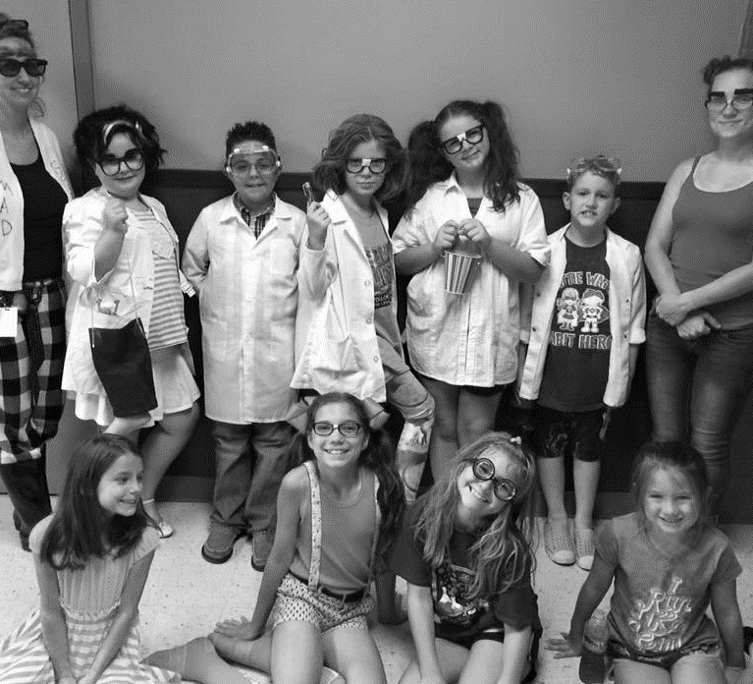
Electron Proton chase
Einstein Says
1-2-3 Asteroid
Bucket Spinning

Snacks:
Popsicles during recess!
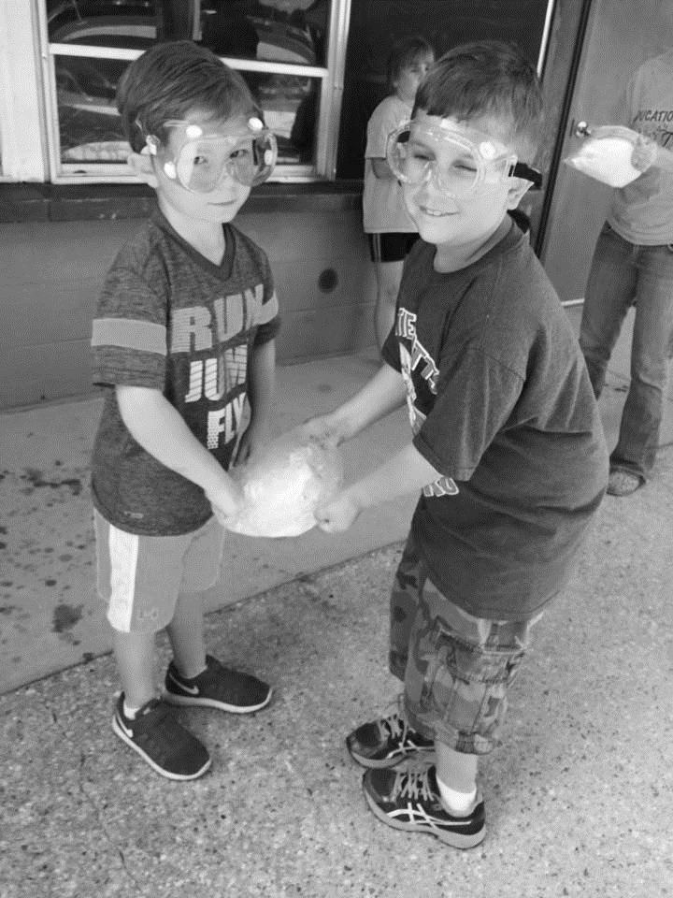
Videos:
Flocabulary Science Raps
Bill Nye the Science Guy
The Dancing Scientist
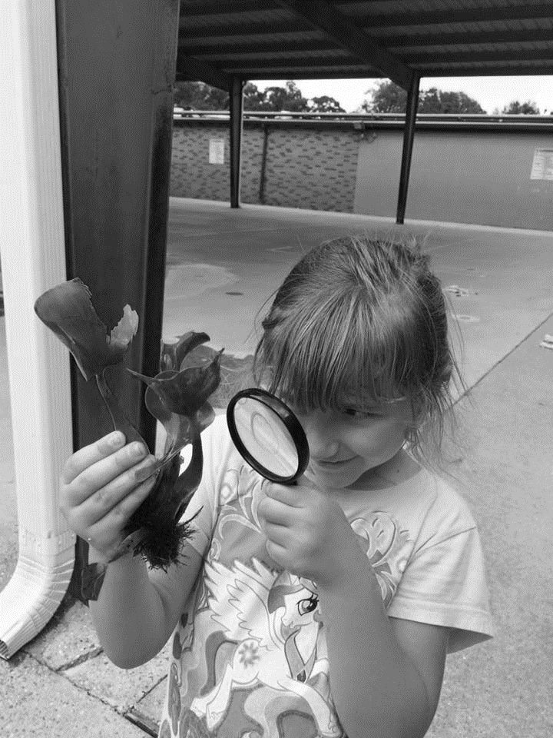
Dress Up Day:
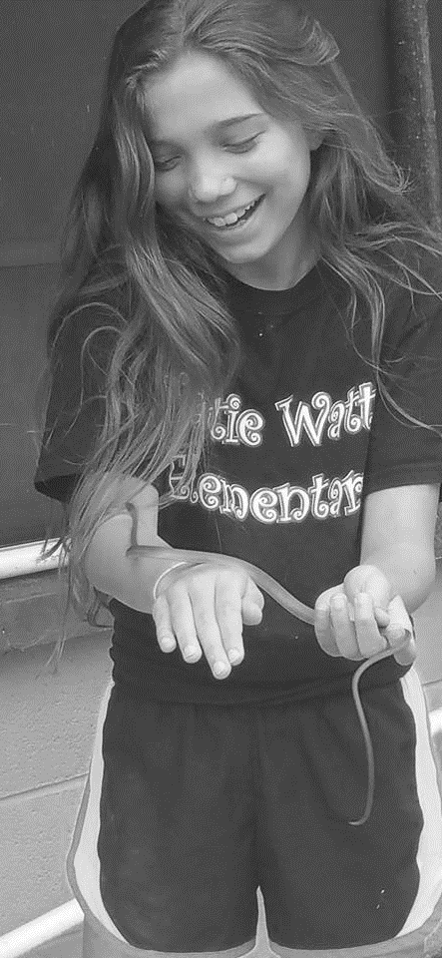
Mad Scientist
